My games in 1st ORC Online Tournament
yyfcsd

In September 2003, the ORC Game Center published and in later half year, more than 1000 players registered and enjoy renju games there. In March 2004, the first formal tournament in ORC game center was hold by a famous Chinese Internet renju club – Renjukings. After that, we are thinking of organizing a tournament for renjuclass members. After discussion by some renjuclass senior members: luwenzhe, span, moocheng, coco_yuang and yyfcsd, Span proposed a plan for ORC Online Tournaments. And 16 renjuclass members signed up for the tournament. So the tournament was to be play in Swiss System with 7 rounds, which meant best players would meet sooner or later.
I am lucky to win the championship this time. It is interesting to share my feeling during the games with all renjuclass members.
The 1st round was played in May 1 as schedule. The day is the beginning of a 7-day holiday in China, so maybe some of the signed-up members not available, which made the tournament a little disappointing.
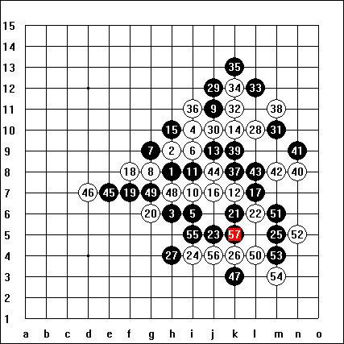
yyfcsd-HEX77 1-0
My first opponent is HEX77, a player comes from Hungary. The pairing result of 1st round was published 1 day before the tournament, so I have time to study my opponent. I collected some of his games in Renjuclass tournament and in Pbem tournament, and decided to open D11 for him. Hex77 not swap and the game went on smoothly to 13th move. His 14th move surprised me a little, because in most of his other games, he used 14-16 instead. I prepared a not bad solution if he played 14-16. But this 14 was ok to me. There are two possible 20th move, 20-20 or 20-27. I played 21-21 without any hesitation after he chose 20-g6 because this variant was just analyzed in Ando’s lesson recently and I wanted to test this 21st move in the game. The idea of the following black moves was to keep the upper-left side active and open while eliminating the possible white development in the lower-right side. If 21-28, 22-29, black’s future development in upper-left side would be not so promising. Hex77’s 26th move was good. In deciding 27th move, I wanted to take g11 point at first look, hoping 28-i11,29-e11,30-f10,31-f12, then black not bad. But finally I find that white can response with 28-k11 if 27-g11, black cannot give up tempo then. So I chose 27-h4, just waiting. Hex77 chose 28-L10, which I think is not a very wise move. Black’s 29 s natural. White has little chance to win in the right side, black took the first key move in this position without any cost. The battle in the right side is not tough. Black turn to left side at 45th move. 46 not strong enough. 47 search for some support and connection with both sides. The four at 48th move is bad, but the 50th move was the last losing move. Not difficult to find the next vct sequence.
In this round, killer21st won against endlessroad quickly while endlessroad chose a wrong variant, Andry was lucky to get 1 point from span in a losing variant. Virag won too with his well-prepared variant. Sunrain chose the similar variant as virag but his 17th move is not good enough and lose the game against celie. Bm and mcmanus took the advantage of their opponents not available.
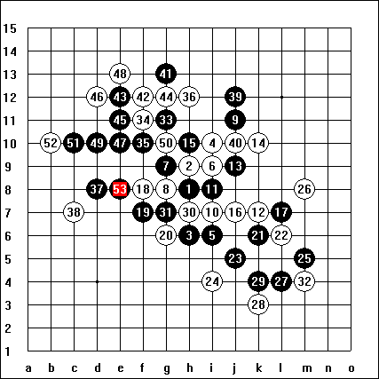
yyfcsd-Andry 1-0
In the next round, I met with andry. I played several games some days before the tournament with him. I used the same variant as in the 1st round till 25. After deep thinking, Andry chose same 26th move as he played with me several days ago, which he lost at last. Actually the game till 33rd move is all same as we played before. I think white is not good enough, it gives black too much space in the upper side. Andry used 34-j12 in previous game where he loses fast in left side, so this time he chooses 34-f11. 35 is a vct threat, so 36 defense is natural. 37 keep on developing in the left side. Andry’s 38th move a little passive, I think 38-e10 maybe better.. 41 want to connect the upper and left side through e11 point, but seem not effective enough if 42 simply cut with e11. But Andry chooses a weaker 42-f12, and the 44th move even worse. If 44-47, black has little chance in this area. After 45, black has strong direct attack and win with vct. A victory day to me☺
In 2nd round, killer21st and bm were under pressure of boyomi and had to end with a draw. Span lost her game. She attacks too directly and after fail the attack she lost tempo and lost the game. Celie won against mcmanus with strong attack. Virag got 1 point from endlessroad with same variant as in the 1st round. Aurora’s win against tianxia surprised me a little. Tianxia choose such a weak variant.
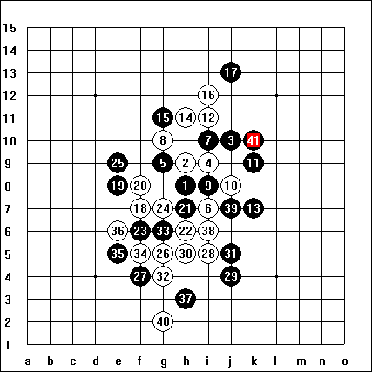
virag-yyfcsd 0-1
In this round, the players with 2 points met. Virag was tentative black this time and open D3 again and gave g9 and i8 as 5th moves. He got 2 points with 5-i8, 11-h11, and I know that he will try this 11 against me again. Although I am confident with such 11, I still chose 5-g9 because I want to surprise him a little more. Till 12th move, all are natural. Virag chose a weaker 13. 18 is sharp style. And 19 here is the strongest. 21 is strong too. If 21-23, then white wins by direct vct from 22-24. 22nd move took me some time. 23? A losing move. The position turn to 21-23 22-24 23-21 24-22. White has vct now. I remember I lost to aivo with 21-23 in email tournament. And there is an article about such variant in past Renjuworld Magazine. Maybe virag didn’t read that article☺. The following moves are all in my preparation after the game with aivo, so 1 point gained.
In this round, killer21st was unlucky again, he had so many chance to win the game with celie, but because of time trouble, he had to end the game with another draw. Span got her 1 point from wolfzhou with a well-known variant. Two Hungarians met: mcmanus and HEX77. mcmanus wanted to surprise the opponent with a irregular 13th move in i11 opening but was anti-surprised by HEX77 with a weak 14th move and lost the game at last.
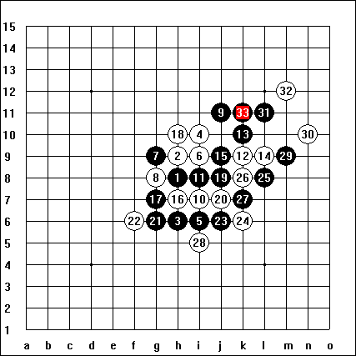
yyfcsd-celie 1-0
My next opponent is celie. I found some of his games when finished the game with virag. He seems prefer D11 opening. And actually he opened D11 for me. I swap with hesitation. The 12th move is not a surprise to me. I played some games with this 12th move. I remembered that I lost one game to span before and had a deep analysis after that about this 12. There are some other 13th moves possible, such as 13-14. In celie’s previous games, I found he used 13-14 once and won that game. But the variant he used maybe just copied from another famous Chinese player(guxingyun)’s game, there is some problem with that way, maybe he did not analyze by himself and most important, maybe he is not familiar with this 12 actually! I choose different 13. I remembered that guxingyun used the same 14 and finally won the game. Maybe celie will copy gu’s game again? I analyzed guxingyun’s game before and find that his win in that game is lucky, his opponent made a mistake and lost. So if celie copied the same move, I have big chance to win the game. And actually he used the same 18 as expected. Black attack immediately with 19 and 21. Indeed, I did not find the black win if 22-23 when I chose this 21, but I fell that black would have a big advantage. And celie’s 22 is the last mistake. I carefully check the winning sequence and then he resigned at my 33rd move. Seems 18-f8 is better although a little passive. And 14-i12 is a not bad choice too.
In this round, virag got his 3rd point from andry while andry made a mistake in D3 opening. Aurora won against endlessroad easily. Mcmanus used an old variant in D11 opening and satisfied with a win. Span got another point easily, since his opponent not available, but the disadvantage is: her Berg is too low.
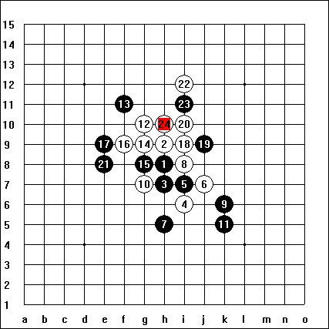
killer21st-yyfcsd 0-1
Maybe this game is a surprise to all observers. It was finished in 15 minutes. Actually it is difficult for me to choose opening for killer21st. Finally I choose d8 and killer21st swap. The 4th move was prepared. 5 and 6 and 7 all natural. We have advanced homework of similar variant in i9 opening. But no correct answers received. The win if 8-h6 is proved at that time, and recently win if h4 also proved. But this 8 and 10 not popular. Yamaguchi met with these 8 and 10 in Shanghai tournament in May 1, he failed attack at last and end his game with draw. Killer21st must have analyzed that game and he is a active style player, I know he will choose some sharp style. I had prepared some of them, include the 11th move he used in the game. White will lose if defense passively and only vct can save from lose. Fortunately there is a white vct. All of the following moves are forced till win.
Only 4 games in this round because some players not available. Virag continued his winning way in d3 opening with his opponent answered with a bad 10th move. Andry’s opponent defended too passively and get him 1 point. Span is unlucky this time. Her opponent bawangwan appeared after giving up the previous 4 rounds☺. A really good game, bawangwan smile at the end.

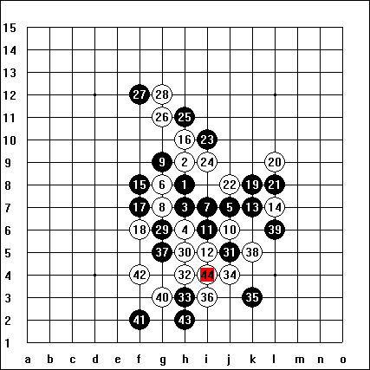
yyfcsd-Aurora 0-1
I knew little about Aurora before the game. But I am confident to get at least 0.5 point from her before this disaster game. I am absolutely wrong. I choose a weak 11th move to surprise her, but seems she is familiar with it. The first trap failed. And the attack of 23 and 25 is not natural, Aurora defended very well with 24 26 and 28. There are so many 31st moves possible, but I chose the losing one. I thought she needs time to calculate the best development and I have chance to win by time What a foolish thinking! Aurora took not much time to find the winning way. Very nice attack after 33rd move. Don’t look down to any of your opponents!
Virag won against celie with his another favorite variant. And he got 5 points now, I have 5 points too, the champion depends on the last round! Killer21st got 1 points from andry and sunrain lose a winning chance under time pressure and got draw with HEX77.

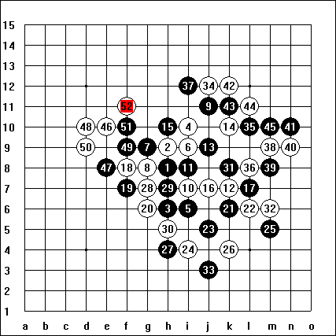
bm-yyfcsd 0-1
The last round began. My opponent is bm. I choose D11 and he swapped. The moves till 26 same as my first game with HEX77, but this time I am white. Seems bm copied my moves☺. He chose the same 27th move as me. The idea of 28 is simply: waiting and let black chose the direction. Black’s moves not strong enough, I think. Black needs to stretch to left side as soon as possible. White 46th move takes the key point of this position. 47is the final mistake. After 48th move, white is so strong at the corner. 51st move not strong too, after 52, white has sure win and bm resigned.
And I am lucky to win the champion after killer21st won against virag. Virag played a little strange, not very strong and his 33rd is a weak move. Killer21st attack nicely and win by vcf.

A nice tournament! I hope next time there will be more renjuclass members take part in such tournament, it can be part of renju studying.

